ENDOCRINE SYSTEM

Exocrine- secrete into duct that carries the secretion to the body surface/cavity eg. Sweat

Endocrine- glands that secrete hormones into extracellular fluid of the cells that make up a gland eg. pancreas

HORMONES
Chemical messengers transported via the blood. They change functioning of cells by changing the proteins produced. They affect target organ or cells

Effects of hormones in a cell:
-Activate certain genes (start production of an enzyme or structural protein)
-change shape or structure of an enzyme (turn it on or off)
-change rate of production (change transcription and translation)

Steroid hormones: lipid soluble such as oestrogen or progesterone
-bind to and travel via transport protein in blood
-hormone diffuses across the cell membrane at the target cells
-in the cell they combine with a receptor protein
-hormone receptor complex activates genes (by changing the protein)
This is slow to have an effect, but is long lasting

Protein/amine hormones: water soluble such as insulin
-travel in the blood plasma
-attach to receptor protein on the membrane of the target cell
- this combination causes secondary messenger substance to diffuse
-this will diffuse through the cell and activate enzymes

Hormone receptor: proteins are specific and will only bind with a certain molecule type, such as the lock and key theory. When each receptor is bound to a molecule, there is no increase in activity

Enzyme amplification: hormones trigger a cascading effect. Number of reacting molecules increases at each step of process. Displaying how one small stimulus can produce a very large effect

Hormone clearance: once it has done its job, the hormone is no longer required. It breaks down inside the target cell with help of particular enzymes. Or it is Transported to liver or kidneys to be broken down and excreted in bile or urine

HYPOTHALMUS
Regulates the function of the body (heart rate, water balance, temp)
Regulates (increases and decreases) secretion of other glands
Located in the base of brain (above pituitary), relative size of an almond
Secretes releasing (increase hormone secretion) and inhibiting factors (decrease secretion)
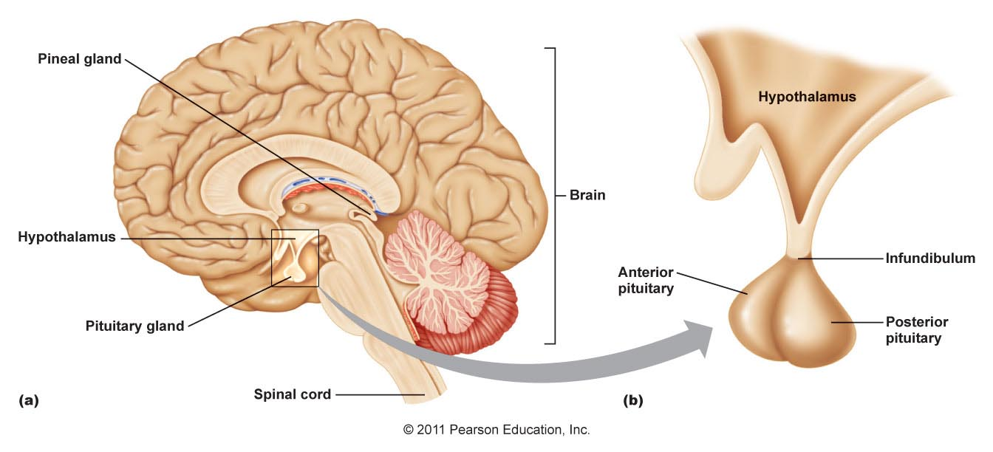
PITUITARY
Joined to the hypothalamus by a stalk- infundibulum
Anterior and posterior sections, function separately to each other

Anterior:
Secretes and produces hormones
Connected to hypothalamus by blood portal system in infundibulum
Releases a number of hormones that regulate body activity
Controlled by releasing and inhibiting factors from hypothalamus

Posterior:
Only secretes hormones (oxytocin and antidiuretic hormone), cannot produce them
Both hormones produced in hypothalamus, and stored in axon terminals
When a nervous signal occurs, they travel to PPG through infundibulum

Hormones secreted:
APG
HORMONE | ORGAN | MAIN EFFECT
Follicle stimulating (FSH) | Ovaries  Testes | Growth of follicle  Production of sperm
Luteinising hormone (LH) | Ovaries  Testes | Develop corpus luteum, ovulation  Secretion of testosterone
Growth hormone (GH) | All body cells | Growth and protein synthesis
Thyroid stimulating (TSH) | Thyroid gland | Secretion of hormones
Adrenocorticotropic (ACTH) | Adrenal cortex | Secretion of hormones
Prolactin (PRL) | Mammary gland | Milk production

PPG
HORMONE | ORGAN | MAIN EFFECT
Oxytocin (OT) | Mammary Glands | Contraction of uterus (birth)  Release of milk
Antidiuretic (ADH) | Kidneys | Reabsorption of water

PINEAL
Located deep inside the brain, secretes melatonin, which is involved in the regulation of sleep patterns. It is stimulated by dark and inhibited by light.

THYROID GLAND
Secretes thyroxine and triiodothyronine
Thyroxine is made of iodine and amino acid and is manufactures in thyroid
Thyroxine stimulates metabolism and growth by regulating reactions of molecules
It controls body temperature due to the release of energy
Thyroid stimulating hormone releasing factor is released from hypothalamus
Thyroid secretion is regulated by thyroid stimulating hormone from APG

Feedback loop:
- Thyroxine concentration in the blood is too low
- Hypothalamus releases TSHRF via blood portal system in infundibulum
- APG releases thyroid stimulating hormone
- Thyroid follicle releases thyroxine
- Increase thyroxine concentration in blood, increases heat, homeostasis restored

Thyroid gland produces calcitonin
It regulates calcium and phosphate concentration (decreases it) it does this by:
- Inhibiting activity of osteoclasts (calcium remains in bone)
- Decreases reabsorption of calcium in the kidney (excreted by urine)
- Inhibition of absorption in the intestines (removed as waste)

If phosphate too high- calcitonin acts to move it into bone and reduce the amount absorbed in the kidney

PARATHYROID GLAND
Tiny masses on the posterior of the thyroid
Secretes parathyroid hormone, increases calcium and phosphate concentration in the blood
- Increasing release of calcium from the bones
- Increased calcium absorption in the kidney from urine
- Increased calcium absorption by the small intestine

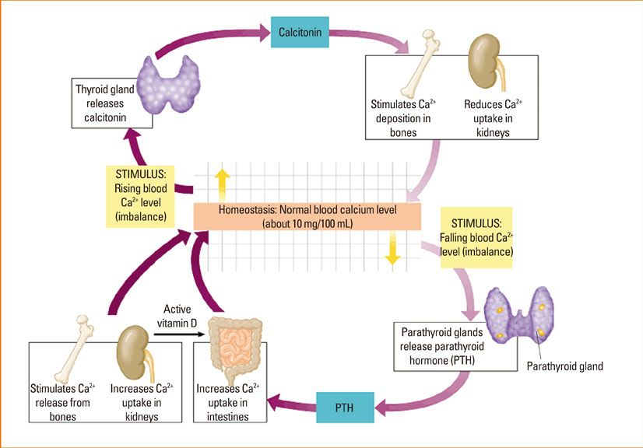
*partner with calcitonin

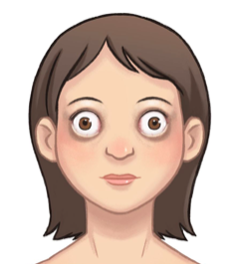
HYPERTHYROIDISM
Overactive thyroid= fast metabolic rate
Rapid heartrate, weight loss, anxiety, sweating, protruding eyeballs
Treated with the removal of the thyroid or drugs to supress thyroid release
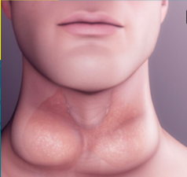
HYPOTHYROIDISM
Underactive thyroid, lack of iodine, attack on thyroid gland
Slow heart rate, weight gain, fatigue, intolerance to cold, goitre (hashimoto disease)
Treated with synthetic tablets, effects 6/10% of Australian women

ADRENAL GLANDS
Located in a triangle-shaped gland above the kidney
Medulla- inside
Secretes Adrenaline and Noradrenaline- targets liver and stimulates glycogenolysis (fast)
Cortex- outside
Adrenocorticotropic hormone travels from APG and triggers release of corticosteroids
Aldosterone: acts on kidney to reduce sodium and potassium retention
If NA too low- kidneys cannot regulate water and salt = a drop in blood pressure and volume
Cortisol: promotes natural metabolism, withstand stress, repair tissues, slow glycogenolysis
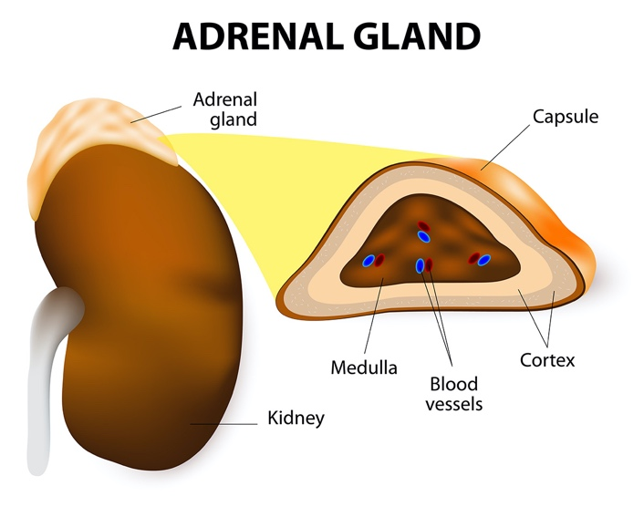
- Stimulates glycogenolysis in the liver
- Breakdown of fatty acids (used as energy)

SHORT-TERM STRESS RESPONSE
Nervous stimulation (fast)
Glycogen is broken down to glucose (glycogenolysis), increases blood glucose conc
Increased blood pressure, breathing rate, metabolic rate
Decreased digestion, increased alertness, blood flow pattern changes

LONG-TERM STRESS RESPONSE
Hormones in the bloodstream- slow effect
Aldosterone: retention of sodium and water in kidneys
Increased blood pressure and volume
Cortisol: suppression of immune system, protein/fat broken down, increase blood glucose

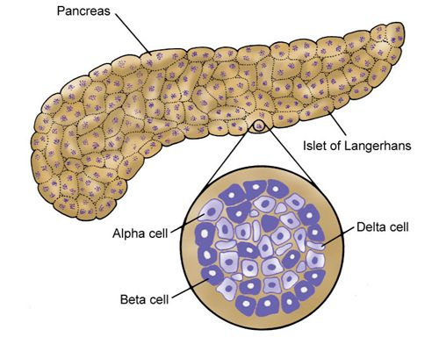
PANCREAS

Insulin- Secreted by beta cells in islets of Langerhans
decreases blood glucose concentration in the blood, through glycogenesis
In the skeletal muscle- uptake of glucose used for energy (stored as glycogen)
In the liver- the uptake of glucose -glucose is transformed into glycogen (glycogenesis)
In adipose tissue- uptake of extra glucose, turning it into fat (lipogenesis)

Glucagon- secreted by alpha cells in islets of Langerhans
increases blood glucose concentration in the blood through glycogenolysis
Liver- glycogen converted into glucose to be used by the body
Adipose tissue- lipogenolysis, glycogen into glucose
Stimulates effects of the sympathetic nervous system

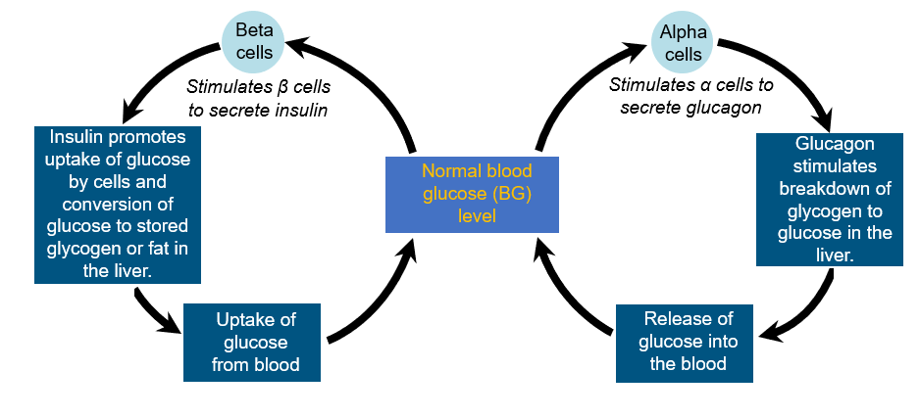

GLAND | HORMONE | TARGET CELLS | MAIN EFFECTS
Thyroid | Thyroxine | Bones and kidney | Increase metabolic rate  Decrease calcium and phosphate  Increase heat and consumption
Parathyroid | Parathyroid | Bones and kidney | Increase level of calcium in blood
Adrenal cortex | Aldosterone  Cortisol | Kidney  Most body cells | Increase reabsorption of calcium  Excretion of potassium  Repair damaged tissue  Deal with long term stress
Adrenal medulla | Adrenaline  Noradrenaline | Most body tissues | Fight or flight response
Pancreas | Insulin  Glucagon | Most body cells  Liver and fat storage | Stimulates uptake of glucose  Lowers blood glucose level  Stimulates glycogenolysis  Increases blood glucose level

Alzheimer’s and Parkinson’s

Embryonic stem cells- found in fertilised eggs (inner mass of blastocyst), only a few days old
Can develop into most cells/ organs/tissues of the body (pluripotent)
Positive- can be used now, very versatile
Negative- unethical, can grow tumours (uncontrolled growth), can be rejected by the body, may not be stable over long periods of time

Induced pluripotent stem cells- derived form reprograming adult cells to act like embryonic
Pluripotent- can become most cells/ organs/tissues of the body
DNA in adult stem cell must be changed permanently into an IPS cell
Positive- easy to obtain (through blood sampling), no ethical concerns, body wont reject
Negative- cannot be used now (not enough info), can grow too large, mutations can occur

Stem cell therapy- Immature cells that can differentiate into mature/specialised cells
Promotes repair response of injured/dead/diseased/dysfunctional cells
Reduces inflammation and modulates the immune system
Not a cure, allows body to mitigate and heal symptoms- increase quality of life
Administered through IV or injection into spinal cord or problem area

Alzheimer’s disease – progressive disease
Formation of abnormal deposits of protein in the brain
Amyloid forms plaques outside the cell, tau forms tangles inside the cell
Damages nerve cell endings, causing them to die, brain loses tissue and shrinks
Hippocampus first effected- hard to form new memories
Amygdala next effected- hard to remember old memories, tend to only remember emotion
Brain has lower levels of neurotransmitter- acetylcholine, cells communicate less effectively
Symptoms- memory loss, struggle with speech, visual and communication, disoriented
Treatment- Donzepil helps to reduce anxiety, increase memory and motivation, boosts levels of chemical messengers in the brain, improves concentration
Stem cell treatment- not yet approved
Using IPS to grow neurons that have same genetic background as the patient
Difficult to achieve as each case is unique and difficult to treat
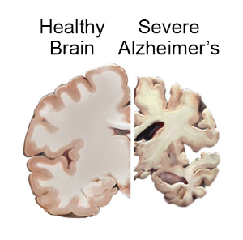
The new created neuron may not represent an aged brain cell
Does not stop the cause of AD, treatments may not last, possible relapse

Parkinson’s disease- neurodegenerative disease
Affects dopamine producing neurons, cause is unknown, affects coordinated movement
Dopamine produced in the Substantia nigra and as the neurons die so does the S.N
When dopamine levels drop by 60-80% symptoms become apparent (chronic)
Develop abnormal protein clumps- Lewy body in brain, made from alpha synuclein protein
Symptoms- Decreased smell, constipation, voice changes, bad posture, tremors
Severe: depression, anxiety, memory loss and hallucinations
4 motor issues- slow movement, posture, stiffness and balance
Treatment- Levodopa drug that helps to replenish dopamine levels, given with carbidopa which reduces the breakdown of levodopa, can be given through pump next to small intestine
Deep brain stimulation: implant electrodes into the brain, generator sends impulses to the brain to help reduce symptoms
Stem cell therapy-
Created in a lab, removing ethical concerns, stem cells injected into 14 parts of the brain
Hoping to boost neurotransmitter dopamine, help to treat motor symptoms
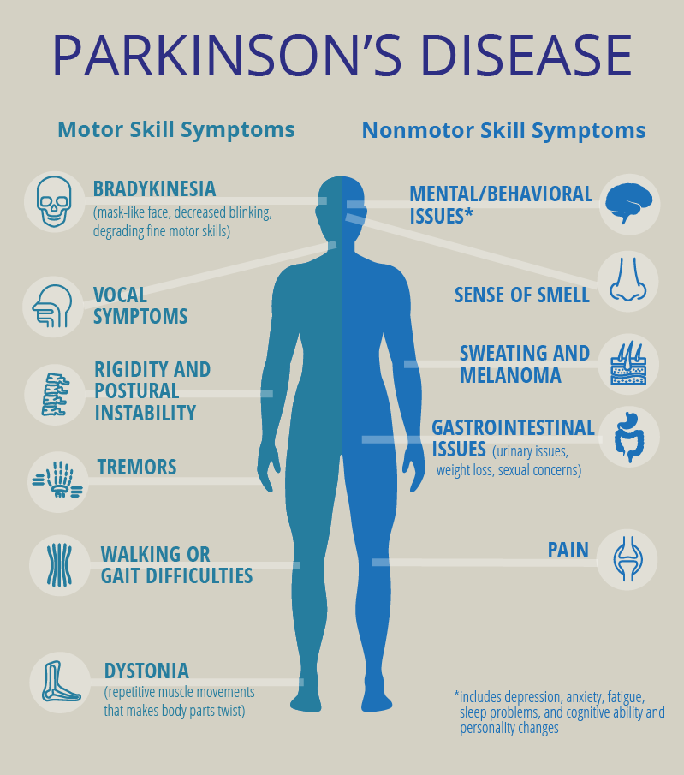
IPS cell- made from adult skin cells in a lab, grow the cells in lab to be IPS
Embryonic- used currently, inner mass of blastocyst taken
Then used to create dopamine producing neurons, transplanted then to patient (both types)

2016 Trial: Millions of stem cells were injected at 14 sites in the patient's brain. Before the human trial he and his colleagues spent weeks practising on a 3D model. The challenge was to do it in a way that you minimise the number of times that you pass your instrument through the brain, to minimise the damage. This is an unfertilised egg activated in a lab, so there are no ethical issues.

